Project Charter

**Project Name:** Benefits and Administrative Product Team (BAAT)

# Project Description and Purpose:

Uniworld Employee Benefit & Payroll Experience

Uniworld would like to provide more user-friendly access to their benefits and payroll information through a centralized platform. With the acquisition of Whistle While You Work, there is a need to modernize their employee experience.

The BAAT project aims to address this need by developing a user-friendly website that provides secure and intuitive access to all aspects of employee benefits and payroll, enabling Uniworld employees to manage their personal information easily. This initiative would also align with the goals of Uniworld to enhance employee satisfaction, streamline HR operations, and ensure compliance with regulatory requirements.

# Measurable Objectives and Success Criteria:

1. **Time**
   1. MVP must be delivered by the end of sprint #4

# Functionality

* 1. The MVP must provide all following features including, but not limited to, the following:
     + Instant access to all employee benefit information
     + Accessibility 24/7, multiple locations, and branches
     + Access to all medical benefits such as medical, dental, prescription, vision, flex spending, 401k
     + Concise explanation of all benefits
     + Downloadable sample employee handbook
     + Documentation of all coverage
     + W-4 Maintenance
     + Clear explanation of commonly used terms
     + FAQ

# Compliance

* 1. The website must comply with all federal and state regulations regarding employee benefits and payroll information. Any vulnerabilities must be addressed to ensure confidentiality of data.

1. **Stakeholder Alignment**
   1. Alignment among key stakeholders. Please refer to the stakeholders section for more information of all stakeholders.
2. **Performance**
   1. Website must be able to respond to all requests in less than 2 seconds and work with all major browsers

**Summary Milestones Schedule:**

|  |  |  |  |
| --- | --- | --- | --- |
| **Milestone** | **Milestone Description** | **Deliverable** | **Applicable Date** |
| 1 | Completion of website requirements & end of sprint 1 | Led by the Product Owner and Scrum Master. This will include finalizing the requirements for the website based on the project kickoff. We will include a document detailing functional and non-functional requirements, user stories, acceptance criteria, and wireframes for the website and complete the 1st sprint. | 5/1/24 |
| 2 | Completion of Website Design & end of sprint 2 | Create the user-friendly layout with design mockups, UI/UX, branding, and styles guides to follow Uniworld’s branding and compliance requirements | 5/15/24 |
| 3 | Completion of integration of Employee Benefit Data & end of sprint 3 | Integrate employee benefit data from HR database into website ensuring confidentiality and security such as data mapping and a functioning backend system while also documentation and user acceptance is complete. | 5/29/24 |
| 4 | Completion of Benefit Enrollment Online & end of sprint 4 | Develop and allow enrollment functionality such as validation and verification checks, confirmation messaging, and UI to allow employees to enroll safely. Code has been peer reviewed. | 6/13/24 |
| 5 | Launch MVP | Set live the fully functional website to employees with current features developed for usability and enrollment purposes. | 6/27/24 |

**Table 1: Project Milestones**

**Project Budget:**

|  |  |
| --- | --- |
| **Budget Description** | **Value** |
| Project Management & Requirement planning | $7,000 |
| Website Design | $20,000 |
| Website Development | $50,000 |
| Website Testing & Deployment | $20,000 |
| Software | $5,000 |
| Hardware | $10,000 |
| **Total** | **$112,000** |

**Table 2: Project Budget**

**Roles:**

|  |  |  |
| --- | --- | --- |
| **Name** | **Role** | **Description** |
| Rahul Kotian, Omkar Salokhe, Siian Rancharan, Nawal Ahmed, James Pi, Farley Gnu | Product Owner | Responsible for product backlog, alignment between stakeholders and defining vision, feedback and decisions. |
| Michael Russell | Project Sponsor | Provides guidance and resources to ensure project success and monitors progress while managing the risks. |
| Farley Gnu, Rahul Kotian, Omkar Salokhe, Siian Rancharan, Nawal Ahmed, James Pi | Scrum Master | Ensures team adheres to scrum principles and supports product owner and project development and progress. |

**Other Stakeholders:**

Philip Bowden, Manager of Payroll

Susan McFee, Manager of Benefits

|  |  |  |  |  |  |
| --- | --- | --- | --- | --- | --- |
| **Name** | **Department** | **Role** | **Influence Over Project (H/M/L)** | **Impacted by Project (H/M/L)** | **Engagement (Participate/Inform)** |
| **Philip Bowden** | HR | Manager of Payroll | H | M | Inform |
| **Susan Mcfee** | HR | Manager of Benefits | M | M | Inform |

Our Product Vision :

**To empower Uniworld employees by revolutionizing their benefits experience. We’ll create an intuitive, secure platform that streamlines access to personalized benefits, fosters engagement, and supports well-being. Through ongoing innovation and collaboration, we’ll build a dynamic hub that adapts to the evolving needs of our workforce.**

**Release Plan:**

|  |  |  |
| --- | --- | --- |
| **Sprint** | **Name of Release** | **Release Date** |
| 2 | Minimally Viable Product (Release 1) | 6/24/2024 |
| 3 | BAAT_Version 1.1 (Release 2) | 7/8/2024 |
| 4 | BAAT_Version 1.2 (Release 3) | 7/22/2024 |

The above table showcases the release plan, the name of the release and the dates of the releases. The release dates are exactly 2 weeks after the start date of the previous release which signifies **one sprint**. The Release date of the Minimally Viable Product is 6/24/2024, which is 2 sprints or 4 weeks from the date of the start of the first release. **There will be 3 releases planned** in the four sprints.

Even after 4 sprints, there are 6 user stories that remain which will then make the backlog. They can be released later as patches to the website.

Release Description.

**Minimally Viable Product (Release 1):**

This release comprises the user stories and tasks that make up the Minimally viable product. This release houses some of the important tasks and user stories related to payroll, taxes, enrollment of benefits, stock purchase program and information, along with details on tax documents and where to access them. This release is primarily focused on paystubs, taxes, and benefits, working its way towards building the Minimally Viable Product (MVP). These user stories are chosen as they provide the highest business value and are included in the MVP.

**BAAT_Version 1.1 (Release 2):**

The second release after the Minimally Viable Product comprises of all the user stories that are not included in the MVP but provide enough business value to merit a fast follow up deployment post MVP. This release plan comprises of some user experience user stories and tasks that benefit the user and aid their use of the website. Especially user stories like the ability to view paystub from any pay period, set up automatic deposit, and submit education request, can all benefit the primary users of this website.

**BAAT_Version 1.2 (Release 3):**

The third release consists of all the user stories that help round up the user experience of the software. They are all good to have, but not required for the functionality of the software.



The screenshot above showing the 4 sprints, the release dates of the software, and the 6 user stories that remain in the last as backlog in orange. Each different color depicts a new sprint, or in the case of the last color, backlog.

Groomed Product Backlog:

The first step in grooming the product backlog is first understanding the stakeholder requirements. By analyzing each desirable feature and breaking the epics down into user stories. Our team’s approach to grooming and prioritizing the product backlog involved focusing on the Minimum Viable Product (MVP) features first, followed by non-MVP items for Uniworld. By prioritizing MVP features, we are making sure that the core functionality (the user stories) that are necessary for delivering value to the users, are developed, and focused early on during the sprints. This would help our team with deployment and feedback early on during the sprint reviews within each of our iteration cycles. The next step is to look at the Business Value Delivered and the Story points and weigh out the benefits of each user story and acceptance criteria for the business payroll and employee benefits experience. The higher the business value a user story has, and the lower the story points comparatively in any scenario, the higher in our product backlog. This can also be seen by creating a value versus effort matrix. To do this, we can plot stories on a matrix based on the perceived business value we are given and prioritize each within a quadrant. This helps us look at the product's overall usability, scalability, and user experience. Story points help us estimate the effort and complexity of an implementation, which we used to plan the sprints and allocate resources moving forward. Also, assigning business value points helped us prioritize user stories that align closely with our teams’ strategic objectives in making this website and accomplishing all the features and goals of the project. By focusing on these metrics, it ensures that our team focuses on delivering the most impactful features first. This approach ensures that our product backlog is groomed and prioritized with necessary, valuable, and complex features early on in sprints, to complete our overall objective. Additionally, we reviewed the acceptance criteria and its clearness to prioritize. For example, user stories that were vague and unclear were pushed ranked less.

Groomed Product Backlog









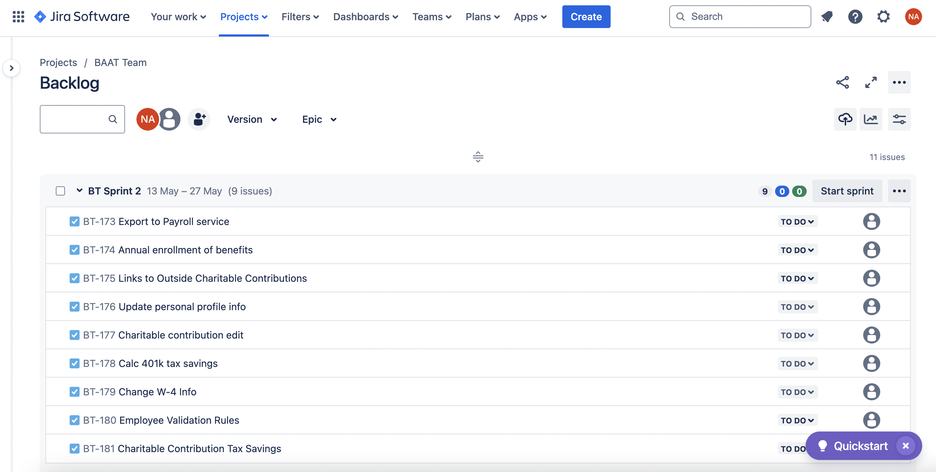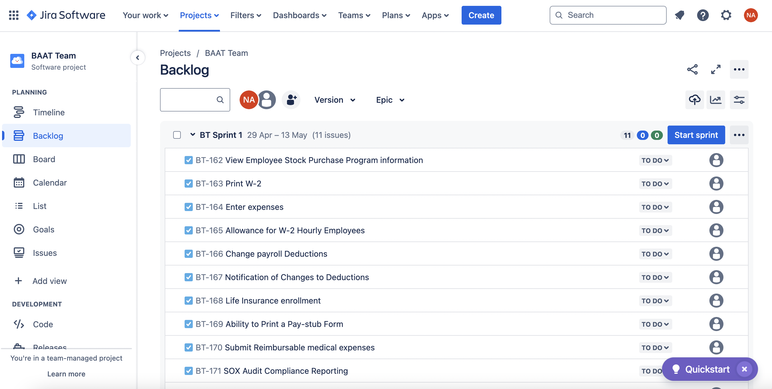

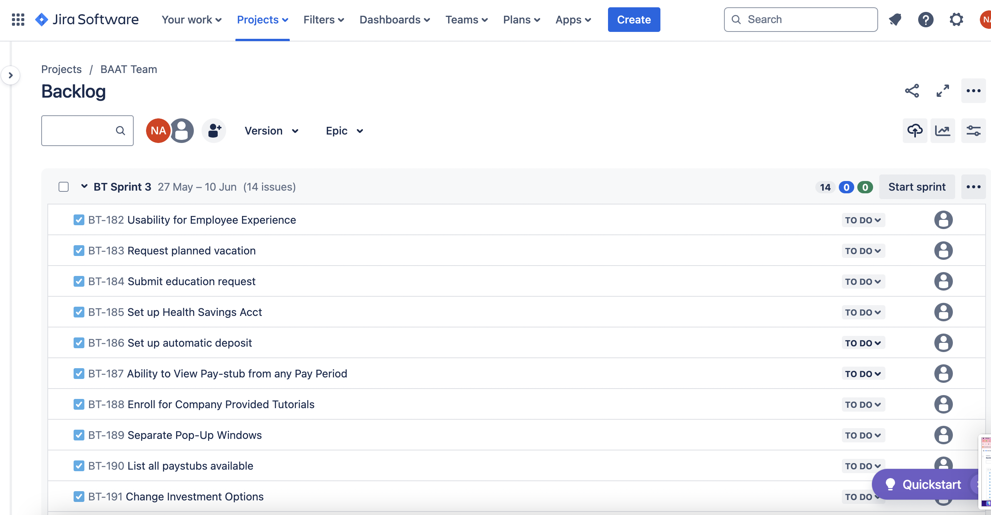

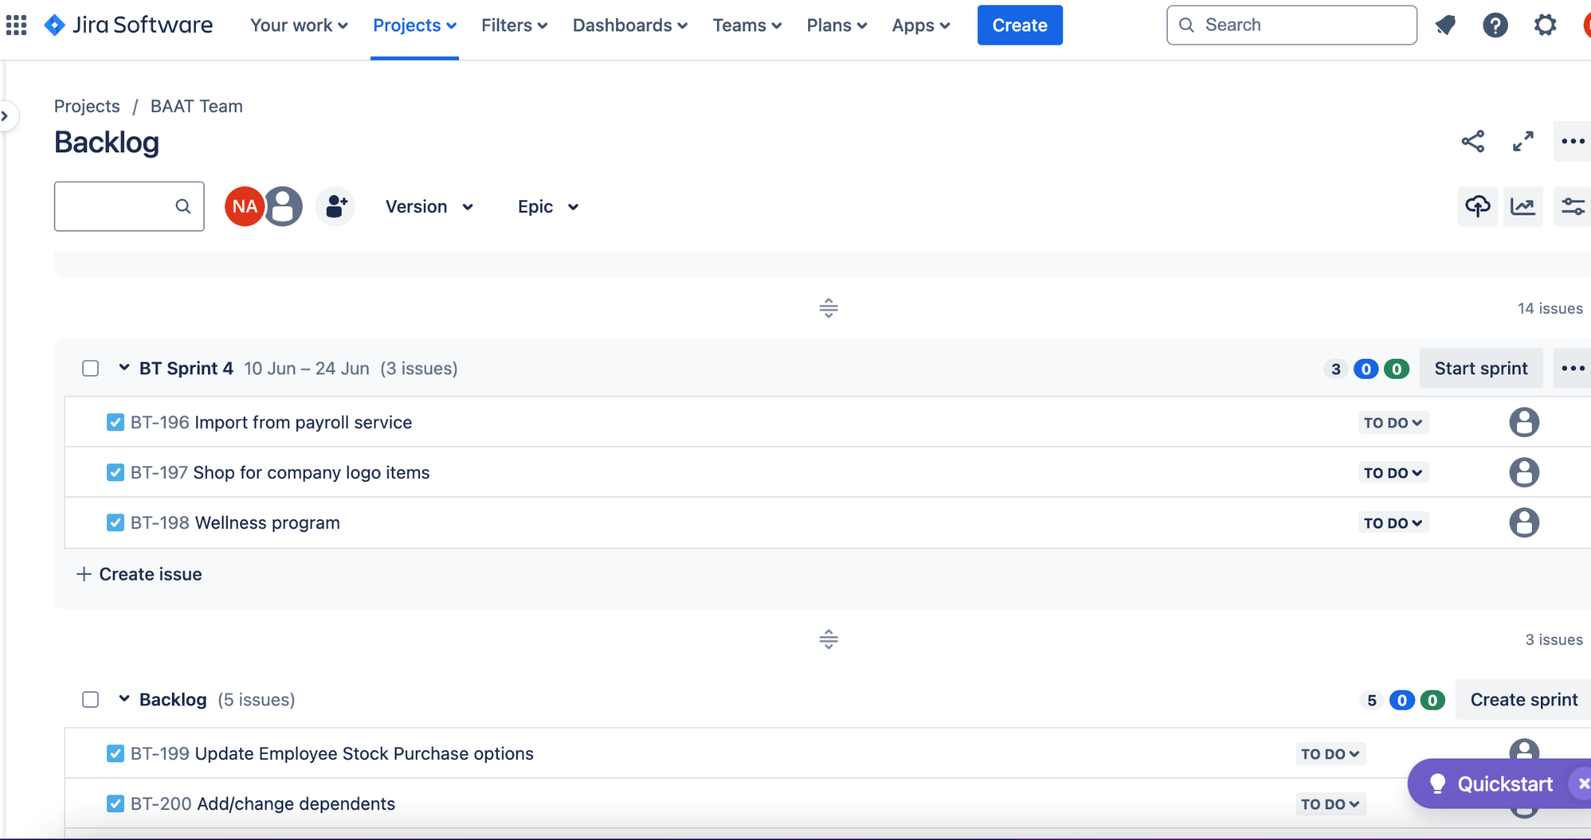

Team Member Contributions (0 to -100)

List and briefly describe the contribution of each team member on this assignment. The description should be one or two sentences at most.

|  |  |
| --- | --- |
| James Pi | Completed all components of the project charter. |
| Rahul Kotian | Product vision and Jira setup |
| Omkar Salokhe | Release Plan, Editing of table to depict number of sprints. |
| Nawal Ahmed | Product backlog description, Jira |
| Siian Rancharan | Grooming of product backlog, editing of document |

**Screenshots of Project Charter in Confluence**

